* Requirement analysis:

suspension system It is what connects the wheel and the body Why do we use it and why is it important? It has many benefits, including that it is able to absorb shocks and vibrations and isolates them from the robot's body when it walks on an uneven road or bumps It also provides stability and stability to the body and makes its movement more smooth It is also important that it makes the wheels touch the road, whatever the obstacle or bump you pass through So now what is required is to design a man for the robot and add a wheel to it .

* Design :

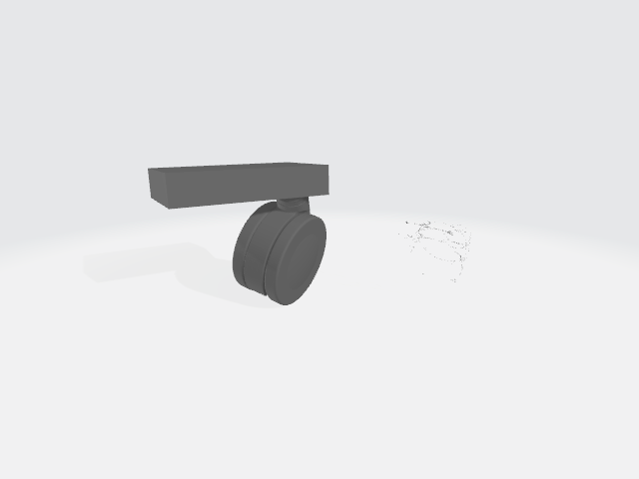

* Testing :

